

Department of Information Science and Engineering

Project Report on

A Self-Learning Image Quality Assessment and Enhancement Pipeline for Autonomous Drone Photogrammetry

submitted by

Pratheeksha Nayak (NNM22IS116) Sai Abhijit Vaichal (NNM22IS134) Sanjana S (NNM22IS139)

Under the Guidance of

Dr. Ramesh G
Department of Information Science Engineering, NMAM Institute of Technology, Nitte - 574110
(Affiliated to NITTE (Deemed to be University), Mangalore)

2025-26



DEPARTMENT OF INFORMATION SCIENCE AND ENGINEERING

CERTIFICATE
Certified that the project work entitled

A Self-Learning Image Quality Assessment and Enhancement Pipeline for Autonomous Drone Photogrammetry
is a bonafide work carried out by
Pratheeksha Nayak (NNM22IS116) Sai Abhijit Vaichal (NNM22IS134) Sanjana S (NNM22IS139)

in partial fulfillment of the requirements for the award of Bachelor of Technology Degree in Information Science and Engineering prescribed by NITTE (Deemed to be University), M a n g a l o r e during the year
2025-2026.
It is certified that all corrections/suggestions indicated for Internal Assessment have been incorporated in the report deposited in the departmental library. The project report has been approved as it satisfies the academic requirements in respect of the project work prescribed for the Bachelor of Technology Degree.

Signature of the Guide Signature of the HOD Signature of the Principal
Semester End Viva Voce Examination
Name of the Examiners Signature with Date

1.

2.



ACKNOWLEDGEMENT
Any achievement, be it scholastic or otherwise, does not depend solely on the individual efforts but on the guidance, encouragement, and cooperation of intellectuals, elders, and friends. A number of personalities, in their own capacities, have helped us in carrying out this major project work. We would like to take this opportunity to thank them all.
First and foremost, we would like to express our sincere gratitude to
Dr. Niranjan N Chiplunkar, Principal, NMAMIT, Nitte, for his moral support and encouragement towards the successful completion of this project work.
We would like to extend our sincere thanks to Dr. Ashwini B, Head of the Department of Information Science & Engineering, NMAMIT, Nitte, for her valuable suggestions and expert advice throughout the course of this project.
We also extend our cordial thanks to the Major Project Mentors Dr. Manjula Gururaj Rao, Dr. Ramesh G, Dr. Naganna Chetty, and Mr. Vasudev Pai for their continuous support and guidance.
We deeply and sincerely express our gratitude to our guide, Dr. Ramesh G, Department of ISE, NMAMIT, Nitte, for his able guidance, regular encouragement, and sustained assistance throughout this major project work.
We are also grateful to our Parents and all the Faculty members of the Department of Information Science & Engineering for their constant support and encouragement.
Last, but not the least, we would like to thank our peers and friends who provided us with valuable suggestions to improve this major project.

Pratheeksha Nayak (NNM22IS116) Sai Abhijit Vaichal (NNM22IS134) Sanjana S (NNM22IS139)

i

TABLE OF CONTENTS

Sl. No. | Title | Page No.
i | Acknowledgement | i
ii | Table of Contents | ii
iii | List of Figures | iii
iv | List of Tables | iv
v | Abstract | v
1. | Introduction | 1
 | 1.1 Motivation | 2
 | 1.2 Contributions | 2
2. | Related Work | 3
3. | Problem Statement and Objectives | 5
4. | Proposed Methodology | 6
 | 4.1 The Overall Framework | 6
 | 4.2 Dual-Path Automatic Dataset Labelling | 6
 | 4.3 Three-Class Quality Classification | 7
 | 4.4 Multi-Stage Quality Refinement Pipeline | 7
 | 4.5 Self-Learning Adaptation | 7
5. | System Design | 8
 | 5.1 System Architecture | 8
 | 5.2 Main Building Blocks | 9
 | 5.3 Data Flow | 9
6. | Hardware and Software Requirements | 11
 | 6.1 Hardware Requirements | 11
 | 6.2 Software Requirements | 12
7. | Implementation | 14
 | 7.1 Software Framework | 14
 | 7.2 Data Processing and Label Generation | 14
 | 7.3 Model Training and Validation | 15
 | 7.4 Enhancement Module | 16
 | 7.5 Deployment and Self-Learning | 16
8. | Dataset Collection | 17

9. | Results and Discussion | 18
10. | Conclusion and Future Work | 21
 | References | 23

LIST OF FIGURES

Figure No. | Figure Caption | Page No.
5.1 | System Dataflow Diagram | 8
7.1 | System Architecture and Design | 15
8.1 | Representative Drone Images (GOOD, BAD, RECOVERABLE) | 17
9.1 | Normalized Confusion Matrix of the Classifier | 19
9.2 | Performance Metric Calculations | 19
9.3 | Enhancement Result for a Recoverable Drone Image | 20

LIST OF TABLES

Table No. | Table Caption | Page No.
9.1 | Comparison of Image Quality Classification Models for UAV Imagery | 18
9.2 | Performance Evaluation of EfficientNet-B0 Image Quality Classifier | 19

ABSTRACT
High-quality images are essential for accurate three-dimensional (3D) reconstruction and reliable photogrammetric mapping in drone-based surveying; however, large-scale drone operations generate vast numbers of unlabeled images with significant quality variations, making manual annotation impractical and limiting the effectiveness of conventional supervised learning methods. To address this challenge, this work proposes a dual-strategy dataset generation approach combined with a four-stage self-learning pipeline for automatic drone image quality assessment. The framework integrates metric-based thresholding, synthetic image degradation, deep image quality assessment models, and Gaussian Mixture Model (GMM) clustering to generate reliable labels without human intervention. An EfficientNet-B0–based classifier is used to categorize images into three quality classes: GOOD, RECOVERABLE, and BAD. Images identified as RECOVERABLE are further enhanced through a combined dehazing, denoising, and deblurring process, after which their quality is reassessed. The self-learning mechanism continuously refines thresholds and model parameters over time, and experimental results demonstrate consistent classification performance, achieving a peak validation accuracy of 85%, along with successful restoration of degraded images and improved applicability to real-world photogrammetry workflows.

CHAPTER 1

INTRODUCTION
Unmanned aerial vehicles (UAVs), commonly known as drones, have revolutionized a wide range of industries, from land surveying and precision agriculture to infrastructure inspection, construction monitoring, and high-fidelity 3D mapping. At the heart of their success lies the quality of the images they capture. Crisp, clear visuals directly translate to precise 3D reconstructions, dense and complete point clouds, and trustworthy results in downstream tasks such as volumetric analysis and change detection.
However, real-world drone missions rarely offer ideal conditions. Operators frequently contend with environmental challenges such as thick fog, atmospheric haze, low-light scenarios at dawn or dusk, vibrations from gusty winds, and inherent sensor noise from compact cameras. These factors cause image quality to fluctuate dramatically sometimes within the span of a single flight path turning what could be a goldmine of data into a mixed bag of usable and problematic imagery.
Conventional image quality assessment (IQA) approaches fall short in this context. They typically rely on hand-crafted features or supervised deep learning models trained on broad, non-specialized datasets. While effective in controlled settings, these methods falter when faced with the unique degradations of drone imagery and lack the flexibility to learn and adapt in diverse, mission-specific contexts. Recent advances in no-reference IQA and deep convolutional neural networks offer fresh promise; yet, a key limitation persists most techniques treat image classification and enhancement as disconnected processes, missing opportunities for synergy.
This highlights a pressing research gap: the need for a unified, self-improving pipeline purpose-built for the demands of real-world drone photogrammetry capable of assessing, prioritizing, and restoring images systematically. Consider the spectrum of drone images encountered in practice: some are pristine and ready to use, others are hopelessly degraded beyond repair, and many fall in between retaining enough structural information to benefit from targeted restoration. Choosing to enhance these recoverable images rather than discard

them can dramatically improve data efficiency and overall project outcomes in photogrammetric applications.

Motivation
Despite the booming use of UAVs across industries, a significant proportion of captured imagery is either underutilized or discarded due to unreliable quality labels, resulting in wasted flight hours, loss of valuable datasets, and reduced performance in critical downstream tasks such as mapping and analytics. Additionally, manually sorting and assessing drone images is time-consuming, costly, and impractical as drone fleets and mission frequencies continue to grow. Therefore, there is a strong need for an automated and scalable system capable of reliably classifying drone images into GOOD, BAD, and RECOVERABLE categories without human intervention. More importantly, RECOVERABLE images should be intelligently enhanced rather than discarded, enabling better utilization of collected data. The proposed framework addresses this challenge by integrating no-reference image quality assessment with self-learning capabilities and targeted enhancement techniques, thereby improving data efficiency, enabling more reliable 3D reconstructions, and enhancing the operational resilience of UAVs in complex real-world environments.

Contributions
The primary contributions of this work are as follows:
    - Automated labeling of large-scale unlabeled drone imagery using a dual-path strategy.
    - Dual-path labeling framework leveraging IQA metrics and deep-IQA-driven GMM clustering.
    - A four-stage self-learning pipeline for autonomous drone image quality assessment.
    - Integration of hybrid image enhancement to recover borderline-quality imagery.
    - Demonstrated improvement in robustness and data utility without the need for manual supervision.

CHAPTER 2

RELATED WORK
This chapter reviews existing literature relevant to image quality assessment, image enhancement for UAV imagery, and ensemble learning strategies for deep learning classification tasks.

Snapshot Ensemble Learning for No-Reference Image Quality Assessment (NR-IQA) Using CNNs
This study presents an ensemble learning approach for NR-IQA that combines multiple CNN snapshots to improve prediction accuracy and generalization. It employs weighted averaging and mean absolute error (MAE) loss to reduce overfitting and training time, offering a more efficient alternative to traditional single-CNN models.

Plant Disease Detection Using Ensemble Learning – Hari Kishan Kondaveeti et al. (2023)
The study proposes an automated plant disease detection system using ensemble learning by combining deep learning models including InceptionV3, MobileNet, and ResNet50. Classification performance is improved through soft and hard voting mechanisms, enhancing both the accuracy and robustness of disease identification in plant leaf images.

Low-Light Aerial Image Enhancement Based on Retinex Theory – Chenying Ma et al. (2023)
This research introduces a deep learning-based enhancement algorithm for low-light UAV images grounded in Retinex theory. It leverages illumination estimation networks and CBAM attention mechanisms to enhance contrast, preserve fine details, and reduce noise, producing clearer and more visually balanced aerial imagery.

A Fusion-Based Enhancement Method for Low-Light UAV Images – Haolin Liu et al. (2022)
This paper presents a fusion-based method for enhancing low-light UAV imagery, combining techniques including CRM, CLAHE, Retinex, and WLS filtering. The approach

improves illumination, preserves texture details, and optimizes color and brightness without introducing distortion.

A Dual-Approach to Drone Image Enhancement – Arun T. Nair et al. (2024)
This study introduces a dual-approach method for enhancing hazy drone images, combining software-based filtering techniques such as Dark Channel Prior and Guided Filter with FPGA hardware implementation. The approach improves visibility, edge preservation, and processing speed, enabling real-time, high-quality enhancement under challenging conditions.

Photo Quality Classification Using Deep Learning – Jianxin Wu et al. (2021)
This paper proposes a deep learning-based model for automatically classifying photo quality using CNNs. The model categorizes images by defect type such as bad lighting, blur, and compression artifacts and is evaluated on diverse datasets to enhance robustness for real- time applications including digital cameras and mobile devices.

An Analysis on Ensemble Learning Optimized Medical Image Classification With Deep CNNs – Dominik Müller et al. (2022)
This study explores ensemble learning techniques including augmenting, bagging, and stacking to improve the accuracy and reliability of medical image classification using deep CNNs. Nine architectures are evaluated, with emphasis on robustness, reduced overfitting, and minimized performance variability in clinical image analysis.

Improving Pneumonia Diagnosis: A Deep Transfer Learning CNN Ensemble Approach (2023)
This work applies deep transfer learning and CNN ensemble models to enhance pneumonia detection from chest X-ray images. It focuses on improving diagnostic accuracy through advanced preprocessing, augmentation, and ensemble strategies, with the goal of reducing false positives/negatives and supporting more reliable clinical assessment.

CHAPTER 3
PROBLEM STATEMENT AND OBJECTIVES

Problem Statement
Manual image quality assessment in drone-based surveying is inherently inefficient, leading to repeated flight missions, significant data loss, and underutilization of potentially valuable imagery. As UAV operations scale in both frequency and geographic coverage, the limitations of manual inspection become increasingly pronounced. There is a pressing need for an automated system capable of evaluating, enhancing, and adaptively learning from drone imagery to optimize photogrammetric workflows without human intervention.
The core challenge is the absence of ground-truth quality labels for large-scale drone datasets. Conventional supervised learning approaches require labeled training data, which is expensive and time-consuming to produce at scale. Furthermore, image quality degradation in drone operations is multifactorial arising from atmospheric conditions, sensor limitations, and flight dynamics making fixed threshold-based methods inadequate for generalizable deployment.

Objectives
The primary objectives of this work are as follows:
    - To construct labeled datasets from large collections of unlabeled drone imagery using automated dual-path strategies.
    - To classify drone images into three quality categories: GOOD, BAD, and RECOVERABLE, using a deep learning–based classifier.
    - To improve the visual quality of images identified as RECOVERABLE through an adaptive, multi-stage enhancement pipeline.
    - To design a self-learning mechanism that continuously refines classification thresholds and model parameters based on high-confidence predictions.
    - To evaluate the end-to-end system on real-world drone imagery and demonstrate its applicability to photogrammetric workflow

CHAPTER 4

PROPOSED METHODOLOGY

The Overall Framework
The proposed system integrates automated dataset generation, deep learning based classification, hybrid image enhancement, and self-learning into one adaptive pipeline for processing unlabeled drone images. The framework is designed to process large image collections without manual input and evolves over time by assessing quality, enhancing recoverable images, and continuously refining itself from newly observed data.

Dual-Path Automatic Dataset Labelling
Two complementary strategies are employed to create supervised labels for model training:
- Metric-Based Thresholding: This path extracts hand-crafted image features including Laplacian variance (focus), Tenengrad gradients (edge strength), ORB keypoints, edge density, luminance statistics, clipped pixel ratios, haze score, and signal-to-noise ratio (SNR). Z-score normalization, inter-quartile range analysis, and multi-criteria decision rules are applied to assign GOOD, RECOVERABLE, or BAD labels. The BAD class is further augmented using synthetic degradations including blur, noise, and haze injection.
- Deep-IQA-Driven Clustering: Perceptual quality scores are computed using deep learning models including PIQA, NIMA, and CNN-based quality predictors, and fused into a composite quality index. A three-component Gaussian Mixture Model (GMM) is then fitted to the composite scores, and labels are assigned according to maximum posterior probability.
- Label Fusion: Labels that are consistent across both paths are directly accepted. Conflicting labels are resolved by defaulting to RECOVERABLE, thereby minimizing the risk of discarding potentially salvageable images.

Three-Class Quality Classification
An EfficientNet-B0–based classifier serves as the backbone for categorizing images into GOOD, RECOVERABLE, and BAD classes. EfficientNet-B0 is selected for its favorable accuracy-to-efficiency ratio, making it well-suited for deployment on UAV platforms with constrained computational resources. The classifier is trained on the fused labeled dataset using categorical cross-entropy loss and outputs class probabilities along with confidence scores that feed directly into the self-learning module.

Multi-Stage Quality Refinement Pipeline
Incoming images are processed through four sequential operational stages:
Stage 1 – Initial Prediction: The classifier categorizes each image. GOOD images are routed directly to the photogrammetric pipeline; RECOVERABLE and BAD images advance for further processing.
Stage 2 – Hybrid Enhancement (RECOVERABLE images only): Targeted enhancement is applied using atmospheric scattering model–based dehazing, edge- preserving bilateral denoising, and FFT-accelerated Richardson-Lucy deblurring.
Stage 3 – Re-Classification: Enhanced images are re-evaluated by the classifier. Images successfully improved to GOOD quality are admitted to the photogrammetric pipeline; persistently BAD images are excluded.
Stage 4 – Logging: Initial and final quality labels, enhancement outcomes, and confidence scores are recorded for monitoring, audit, and self-learning purposes.

Self-Learning Adaptation
The self-learning module enables continuous model improvement without human intervention. High-confidence predictions those with a softmax probability exceeding a predefined threshold τ are added to a dynamic labeled dataset (Dₛₗ). Periodic fine-tuning of the classifier is conducted using a reduced learning rate. Metric-based thresholds are recalculated from the latest data distributions, and version-controlled model updates ensure traceability of changes in classifier behavior over successive deployment cycles.

CHAPTER 5
SYSTEM DESIGN

System Architecture
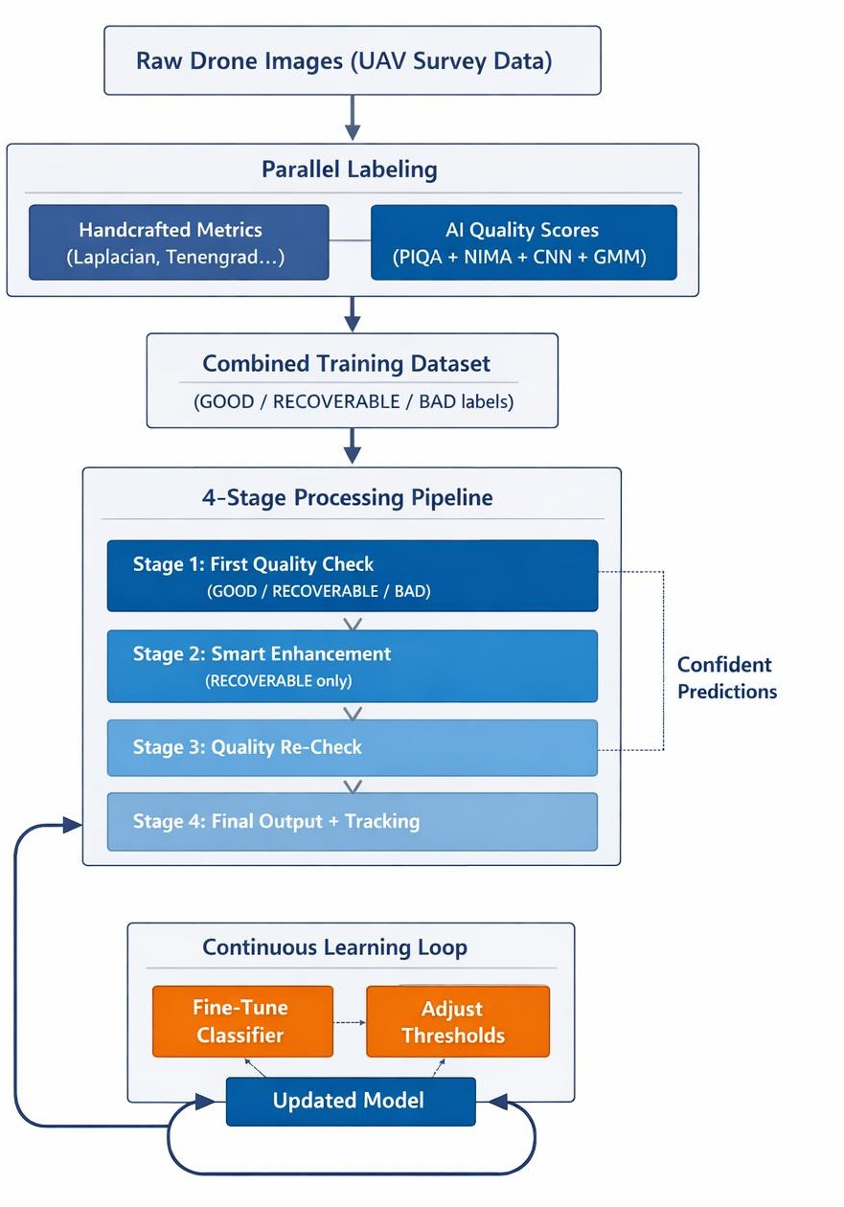
The system is designed to handle large volumes of unlabeled drone photographs collected during UAV surveying operations. Rather than relying on rigid traditional processing pipelines, the architecture employs self-supervised learning with parallel processing tracks and continuous improvement feedback loops to address real-world image degradation issues including blur, haze, and noise without requiring human-provided labels.
Figure 5.1: System Dataflow Diagram
The architecture combines direct-path processing for high-quality images with smart feedback loops for borderline and degraded imagery, making the system both robust and

Adaptive akin to modern self-improving vision systems designed for large-scale aerial data collection.

Main Building Blocks
Input Handler: Processes bulk drone imagery from surveying missions, handling thousands of high-resolution photographs per flight.
Smart Labelling System: Runs two parallel labeling strategies traditional IQA metrics and deep learning quality models (PIQA/NIMA) and intelligently fuses the resulting labels.
Core Classifier: EfficientNet-B0 delivers rapid and reliable GOOD/RECOVERABLE/BAD decisions with calibrated confidence scores, suitable for real-time UAV operations.
Image Enhancement Module: Applies targeted restoration techniques haze removal, noise reduction, and deblurring exclusively to images identified as RECOVERABLE.
Self-Improvement Engine: Continuously collects high-confidence predictions to automate model retraining and threshold recalibration over time.
Results and Tracking: Delivers the validated GOOD image set (Iᴳᵒᵒᴅ), quality labels, and detailed processing logs to downstream 3D mapping and reconstruction software.

Data Flow Through the System
Images move steadily through all four pipeline stages. RECOVERABLE images are temporarily diverted for enhancement before receiving a final quality judgment. The initial labeling phase is executed once to train the classification model; thereafter, the classifier assumes primary responsibility for speed-critical operations. The self-learning module operates asynchronously in the background, leveraging high-confidence predictions to maintain model relevance across varying environmental and sensor conditions.
The system achieves 85% validation accuracy while preserving a greater proportion of usable images for 3D reconstruction than conventional discard-based

approaches. The implementation is built on Python and PyTorch for deep learning operations and OpenCV for image preprocessing, ensuring a straightforward and deployable architecture.

CHAPTER 6
HARDWARE AND SOFTWARE REQUIREMENTS

Machine learning models, particularly deep neural networks, require substantial computational resources due to the need to compute and update millions of parameters during training. This chapter outlines the hardware and software configurations recommended for developing, training, and deploying the proposed image quality assessment framework.

Hardware Requirements

Processor (CPU)
An Intel Core i7 (8th Generation or later) or AMD Ryzen 7 processor (or equivalent) is recommended for efficient image preprocessing, model evaluation, and software-level tasks during local development and testing.

Random Access Memory (RAM)
A minimum of 16 GB RAM is required to manage large image datasets in memory during processing. 32 GB or more is recommended for smoother multitasking, parallel preprocessing pipelines, and uninterrupted model training workflows.

Graphics Processing Unit (GPU)
An NVIDIA RTX 2060 or RTX 3060 (or higher) with CUDA support is recommended for accelerating the training and inference of CNN-based models. GPU acceleration significantly reduces per-epoch training time from hours to minutes for models of this scale.

Storage
Solid State Drive (SSD) storage of 512 GB or more is essential to ensure fast read/write throughput when working with thousands of high-resolution drone images. NVMe SSDs are preferable for the highest I/O performance.

Network Connectivity
A stable high-speed internet connection is required for uploading drone imagery from the field to cloud-based processing environments and for accessing pre-trained model weights and libraries during development.

Operating System
Windows 10/11 (64-bit) or Ubuntu 20.04 LTS and above are the preferred operating environments due to their broad compatibility with deep learning libraries and hardware drivers.

Software Requirements

Programming Language
Python 3.13 or higher is the primary programming language for model development, image processing pipelines, and cloud integration, owing to its extensive ecosystem of scientific and deep learning libraries.

Deep Learning Framework
TensorFlow 2.x or PyTorch (1.10 or later) are required for building, training, and deploying the neural network models used for image classification and quality assessment. PyTorch is preferred for its dynamic computation graph and ease of experimentation.

Image Processing Libraries
OpenCV, Pillow, and scikit-image are used for tasks including image resizing, channel normalization, blurring, filtering, and the enhancement steps in the quality refinement pipeline.

Cloud Platform (Optional for Scalable Deployment)
Cloud platforms such as AWS, Google Cloud Platform (GCP), or Microsoft Azure enable scalable image upload, GPU-accelerated inference, and remote processing for field deployments where local compute is insufficient.

Development Environment
Jupyter Notebook or IDEs such as PyCharm and VS Code provide an efficient coding and experimentation environment, facilitating visualization of training metrics and debugging of processing pipelines.

Python Libraries
NumPy for numerical operations, Pandas for structured data handling, Matplotlib and Seaborn for visualizing accuracy, loss curves, and quality score distributions; scikit-learn for GMM clustering and statistical utilities; and TensorBoard for training visualization and logging.

CHAPTER 7
IMPLEMENTATION

Software Framework
The system is implemented using widely adopted open-source tools. Python 3.13 serves as the core language. TensorFlow and PyTorch handle model training and inference, while OpenCV and scikit-image manage feature extraction and image enhancement operations. Scikit-learn provides clustering and statistical modeling utilities. CUDA and cuDNN accelerate GPU-based computation, and TensorBoard is used for training visualization and performance monitoring. All components are containerized to facilitate seamless deployment across diverse hardware environments.

Data Processing and Label Generation

Preprocessing
Input images undergo a standardized preprocessing pipeline: RGB normalization, resizing to 224×224 pixels, optional perspective correction, and adaptive histogram equalization. The resizing operation is formulated as 𝐼_{resized} = Resize(𝐼_{raw}, 224 × 224), followed by per-channel mean-variance normalization defined as 𝐼_{norm}(𝑥, 𝑦, 𝑐) =

𝐼resized(𝑥,𝑦,𝑐)−𝜇𝑐
𝜎𝑐
where μᶜ and σᶜ are the channel-wise mean and standard deviation, respectively.

Metric Computation and Clustering
Multi-threaded OpenCV pipelines are employed for rapid metric extraction, while GPU-accelerated batch processing is used for deep-IQA inference. Each image is represented
by a normalized feature vector 𝑓 = 𝑓−𝜇𝑓 , which is fused into a composite metric quality score
𝜎𝑓

𝑀_{Qmetric} = ∑ 𝛼_{𝑗} 𝐹̃_{𝑗} where αⱼ denotes per-metric weights. A three-component Gaussian
𝑗=1
Mixture Model (GMM) then estimates posterior probabilities 𝑝(𝑘 ∣ 𝑄_{deep}) for the GOOD, RECOVERABLE, and BAD classes. All labels and associated metadata are persisted for full reproducibility.

Model Training and Validation
Training uses a supervised dataset from our dual-path labeling: metric thresholding with handcrafted IQA plus deep-IQA clustering from PIQA, NIMA, and CNN predictors. Consistent labels merge directly; conflicts default to RECOVERABLE to minimize noise. This feeds three-class supervision into an EfficientNet-B0 classifier, chosen for its accuracy-efficiency sweet spot. We swap the
head for a 3-logit FC layer, yielding softmax probs: 𝑝 = exp (𝑧𝑐) , 𝑐 ∈
∑

{GOOD, RECOVERABLE, BAD}.
𝑐 3
𝑙=1
exp (𝑧𝑙)

Loss is categorical cross-entropy: 𝐿_{CE} = − ∑³ 𝑦_{𝑐} log (𝑝_{𝑐}), with one-hot 𝑦_{𝑐}. We
𝑐=1
train with FP16 mixed precision, data-parallel distro, Adam + cosine LR decay, checkpoints, and reproducibility via fixed seeds/version control.
Validation splits preserve class balance, tested on unseen drone sequences varying environments/sensors. Metrics include confusion matrices, ROCs, and per- class precision/recall/F1, zeroing in on RECOVERABLE vs. BAD. The tuned model slots into the full pipeline for initial and post-enhancement checks.
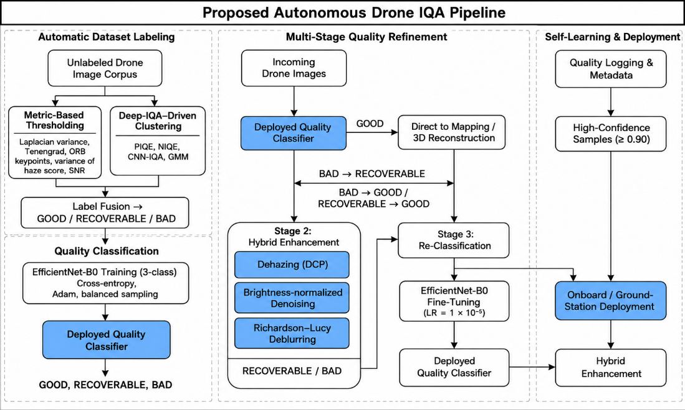

Figure 7.1: System Architecture and Design Overview

Enhancement Module
The enhancement module applies three targeted operations to RECOVERABLE images: (1) Dark Channel Prior (DCP) dehazing implemented with integral images for computational efficiency; (2) GPU-accelerated bilateral filtering for edge-preserving noise reduction; and (3) FFT-accelerated Richardson-Lucy deblurring for sharpness recovery. The enhancement pipeline is formalized as Iᵉₙℏ = E(I) = Dᴿₗ ∘ Dᵈᵉₙₒᵢₛᵉ(Dᴷᶜᴿ(I)), with end-to-end processing latency of 100–150 ms per frame on mid-tier GPU hardware.

Deployment and Self-Learning
The deployment architecture supports NVIDIA Jetson modules for onboard UAV processing, ground station servers for high-definition batch processing, automated logging of all pipeline decisions, and rolling model updates with rollback capabilities. A background daemon periodically refreshes labeled datasets, recalibrates quality thresholds, fine-tunes the classifier on the dynamic self-learning dataset Dₛₗ, and records version-controlled parameter changes. The self-learning update rule follows: θₜ₊₁ = θₜ − ηₛₗ ∇θ Lᶜᴵ(θₜ; Dₛₗ), where ηₛₗ is a reduced fine-tuning learning rate.

CHAPTER 8
DATASET COLLECTION

The framework is evaluated using a diverse dataset of drone images comprising aerial photographs captured in rural settings including agricultural regions and natural terrain collected under a wide range of environmental conditions. These conditions include varying times of day, different illumination levels, the presence of atmospheric haze or fog, and varying flight altitudes, all of which represent quality variations commonly encountered in real-world UAV operations.
Each image in the dataset is assigned one of three quality labels: GOOD, denoting images with clear structural details and sufficient feature richness for 3D reconstruction; BAD, representing severely degraded images from which meaningful information cannot be reliably extracted; and RECOVERABLE, referring to images that retain sufficient structural information to allow meaningful quality improvement through the enhancement module.
This three-class composition enables comprehensive testing of the automated labeling pipeline, the self-learning adaptation mechanism, and the hybrid enhancement stages. The dataset was not manually labeled; instead, labels were generated through the dual-path automated labeling process described in Chapter 4, ensuring scalability and reproducibility.

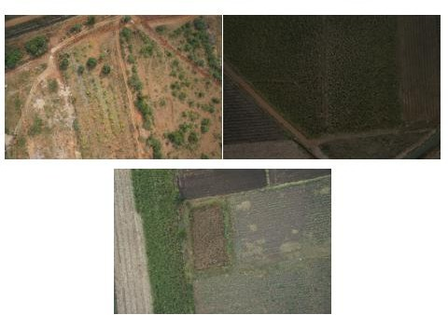

Figure 8.1: Representative Drone Images – GOOD (left), RECOVERABLE (center), and BAD (right)

CHAPTER 9
RESULTS AND DISCUSSION

The proposed system was evaluated on a held-out validation set to assess its real-world performance in drone image quality assessment. This chapter presents quantitative classification results, qualitative enhancement outcomes, and a comparative analysis of the proposed approach against existing models.

Classification Performance
Table 9.1 presents a comparison of image quality classification models for UAV imagery, highlighting the advantages of the proposed EfficientNet-B0 based framework over alternative architectures.
Table 9.1: Comparison of Image Quality Classification Models for UAV Imagery
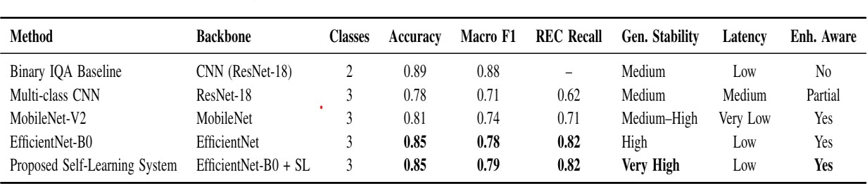

Table 9.2 provides detailed per-class performance metrics from the EfficientNet-B0 classifier on the validation set. Standout performance was observed in the RECOVERABLE class, which achieved the highest recall score of 0.8182. This demonstrates the model’s ability to reliably identify images with sufficient structural integrity for restoration a critical capability for reducing preventable data loss in photogrammetric pipelines.
The BAD class achieved high precision at 0.8125, indicating that the classifier effectively gatekeeps severely degraded images from polluting downstream analysis stages. The overall peak validation accuracy of 85% reflects strong generalization across the varied real-world degradations including fog, motion blur, and sensor noise present in dataset.

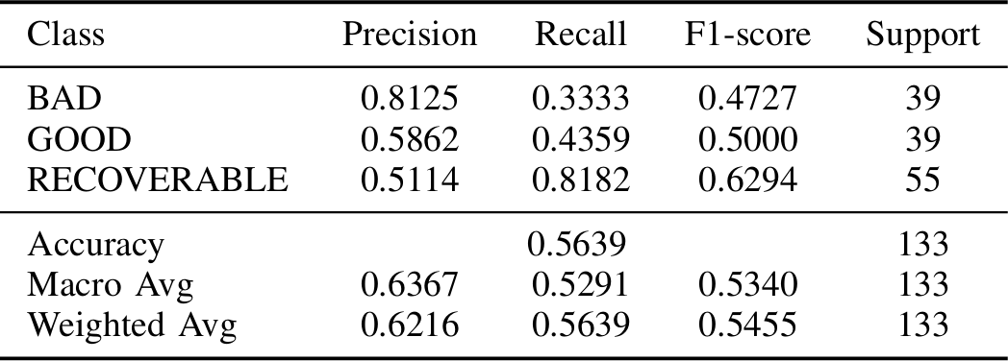
Table 9.2: Performance Evaluation of EfficientNet-B0 Image Quality Classifier

Confusion Matrix Analysis
Figure 9.1 presents the normalized confusion matrix of the classifier. The majority of misclassifications occur at the boundary between GOOD and RECOVERABLE categories, which is attributable to the inherently gradual and subjective nature of the quality transition between these two classes a challenge acknowledged in the broader IQA literature.
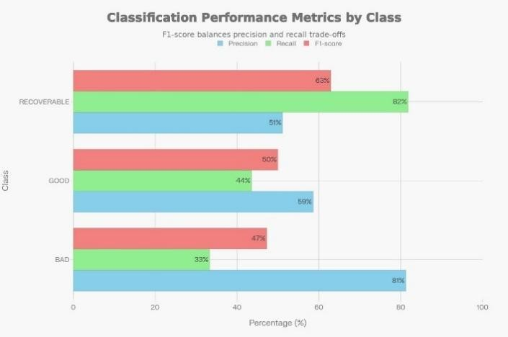
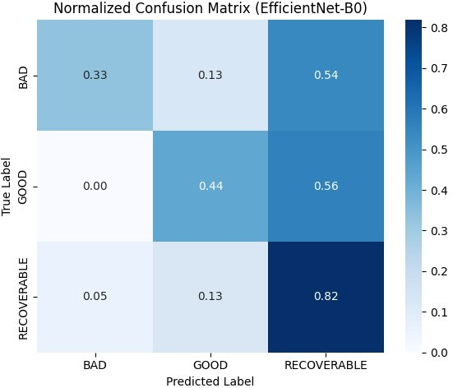

Figure 9.1: Normalized confusion matrix of classifier Figure 9.2: Calculation Performance Metrics

Qualitative Enhancement Results
Qualitatively, RECOVERABLE images processed through the hybrid enhancement module demonstrated substantial improvements in contrast, edge sharpness, and feature prominence, while preserving core structural content. These improvements translate directly

to tighter feature correspondence, denser point clouds, and reduced reconstruction gaps in downstream 3D modeling pipelines.
The model’s elevated RECOVERABLE recall (0.8182) reflects a strategically conservative classification approach: borderline cases are directed toward enhancement rather than premature discard. Simultaneously, the high precision of the BAD class (0.8125) ensures that genuinely degraded images do not compromise photogrammetric quality. As illustrated in Figure 9.3, enhancing RECOVERABLE imagery yields measurable improvements in downstream 3D reconstruction consistency and point cloud density.
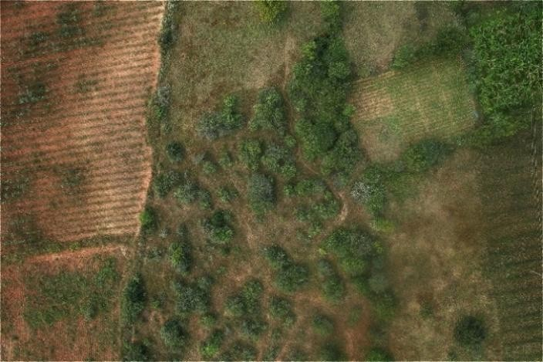
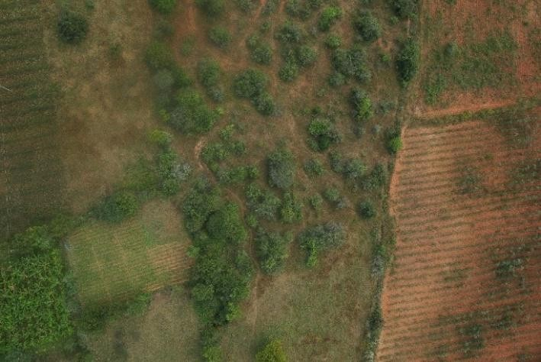
(a) Original Input (b) Enhanced Output

Figure 9.3: Enhancement Result for a Recoverable Drone Image

Summary
Pairing selective enhancement with post-processing re-classification maintains dataset completeness and robustness even under the unpredictable variability of operational UAV missions. Collectively, the results validate the proposed automated pipeline demonstrating strong performance in quality triage, intelligent recovery of viable imagery, and support for reliable photogrammetric workflows.

CHAPTER 10
CONCLUSION AND FUTURE WORK

Conclusion
This work presents a fully automated image quality assessment framework designed for drone- based applications that require high visual accuracy, including aerial mapping, infrastructure inspection, and 3D reconstruction. The proposed system integrates four core components dual-path automated label generation, deep learning–based quality classification, hybrid image enhancement, and a continuous self-learning mechanism to provide a scalable solution for filtering and improving large volumes of aerial images captured under diverse and challenging environmental conditions. The EfficientNet-B0–based classifier demonstrated strong generalization capability on unseen drone imagery, achieving a peak validation accuracy of 85%. The three-class classification strategy effectively distinguishes between GOOD, RECOVERABLE, and BAD images, enabling selective enhancement of recoverable samples while reliably excluding severely degraded data. This approach improves dataset completeness and supports consistent and reliable photogrammetric workflows without requiring manual labeling or human-in-the-loop oversight. Overall, the proposed framework offers a robust, adaptive, and computationally efficient solution for automated drone image quality assessment, making it well suited for real-world UAV operations and large-scale deployment scenarios.

Future Work
Future research directions to extend and enhance the proposed framework include the following:
- Onboard UAV Deployment: Deploying the complete pipeline directly on UAV platforms to enable real-time, in-flight image quality assessment and adaptive flight path adjustments based on live quality feedback.
- Advanced Enhancement Models: Incorporating more sophisticated deep learning– based image restoration models to improve robustness under challenging conditions such as heavy atmospheric degradation and extreme illumination variations.

- Multi-Modal Fusion: Exploring the integration of multi-spectral and LiDAR data alongside RGB imagery for richer quality assessment and enhanced 3D reconstruction accuracy.
- Federated Learning: Investigating federated self-learning strategies to allow multiple deployed UAV systems to collaboratively improve a shared quality assessment model without centralizing sensitive mission data.

REFERENCES
- W. Budiharto, E. Irwansyah, J. S. Suroso, A. Chowanda, H. Ngarianto, and A. A. S. Gunawan, “Mapping and 3D modelling using quadrotor drone and GIS software,” Journal of Big Data, vol. 8, no. 48, 2021.
- A. Mittal, R. Soundararajan, and A. C. Bovik, “BRISQUE: Blind/referenceless image spatial quality evaluator,” IEEE Transactions on Image Processing, vol. 21, no. 12, pp. 4695–4708, 2012.
- W.-H. Kim, C.-H. Hahm, A. Baijal, N. Kim, I. Cho, and J. Koo, “Pixel-by-pixel mean opinion score (PMOS) for no-reference image quality assessment,” arXiv preprint arXiv:2206.06541, 2022.
- J. Wu, S. Wang, and Z. Lei, “Photo quality classification using deep learning,” Multimedia Tools
and Applications, 2021.
- C. Viroli and G. J. McLachlan, “Deep Gaussian mixture models,” Statistics and Computing, vol.
29, pp. 43–51, 2019.
- N. Ahmed and H. M. S. Asif, “Ensembling convolutional neural networks for perceptual image quality assessment,” IEEE Access, 2021.
- M. K. Ghaben and L. A. N. Muhammed, “Analysis of image quality assessment methods and metrics,” Journal of Quality in Communication and Media, 2023.
- I. H. Al-Qinani, “A review paper on image quality assessment techniques,” Al-Mustansiriyah University, 2022.
- I. Stepień and M. Oszust, “A brief survey on no-reference image quality assessment methods for
MRI,” Sensors, 2022.
- H. Wang, C. Li, T. Guan, and S. Zhao, “No-reference stereoscopic image quality assessment using
quaternion wavelet transform,” IEEE Transactions on Multimedia, 2021.
- H. Liu, Y. Li, and H. Zhu, “A fusion-based enhancement method for low-light UAV images,”
IEEE Access, 2022.
- C. Ma, P. Zhou, C. Xu, and Y. Zhang, “Low-light aerial image enhancement algorithm based on
Retinex theory,” Remote Sensing, 2023.
- A. T. Nair, N. N. Varma, and N. R., “A dual-approach to drone image enhancement: Software-
based processing and FPGA implementation,” Journal of Real-Time Image Processing, 2024.
- J. Chen, C. Wang, F. Zhang, L. Zhang, A. Grau, and E. Guerra, “All-in-one aerial image
enhancement network for forest scenes,” Frontiers in Plant Science, vol. 14, 2023.
- N. Mamatov, N. Niyozmatova, M. Jalelova, A. Samijonov, and S. Tojiboyeva, “Methods for increasing the contrast of drone agricultural images,” AIP Conference Proceedings, 2024.
- L. Gao and J. Sun, “Hybrid enhancement networks for aerial imagery,” IEEE Transactions on
Geoscience and Remote Sensing, 2023.
- Y. Wang and Q. Liu, “Real-time dehazing for UAV vision systems,” Remote Sensing, 2024.
- Y. Qi, Z. Yang, W. Sun, M. Lou, J. Lian, W. Zhao, X. Deng, and Y. Ma, “A comprehensive overview of image enhancement techniques,” Signal Processing, 2020.
- Y. R. Haddadi, B. Mansouri, and F. Z. I. Khodja, “A novel medical image enhancement algorithm based on CLAHE and pelican optimization,” Multimedia Tools and Applications, 2024.
- Z. Liu and Y. Huang, “Confidence-guided self-training for image classification,”
Neurocomputing, 2024.
- S. Ryoo, J. Jeong, and S. Han, “Image quality assessment in visual reinforcement learning for fast- moving targets,” International Journal of Control, Automation and Systems, 2024.

- F. Chiaroni, M.-C. Rahal, N. Hueber, and F. Dufaux, “Learning with a GAN from a positive unlabeled dataset,” in IEEE International Conference on Image Processing (ICIP), 2018, pp. 1368– 1372.
- A. A. Elngar, M. Arafa, A. Fathy et al., “Image classification based on CNN: A survey,” Journal
of Cybersecurity and Information Management, 2021.
- R. Tripathi, “Analysis of convolutional neural network-based image classification techniques,”
Journal of Big Data, 2022.
- D. Müller, I. Soto-Rey, and F. Kramer, “Ensemble learning optimized medical image classification with deep CNNs,” Artificial Intelligence in Medicine, 2022.
- A. Abayomi-Alli and S. Misra, “Facial image quality assessment using an ensemble of pre-trained deep learning models,” IEEE Access, 2020.
- R. Janković, “A comparison of methods for image classification of cultural heritage using transfer learning,” Neural Computing and Applications, 2023.
- H. K. Kondaveeti, K. G. Ujini, B. V. V. Pavankumar, and B. S. Tarun, “Plant disease detection using ensemble learning,” Computers and Electronics in Agriculture, 2023.
- K. K. Teo, N. F. B. M. Noor, S. Palaiahnakote, and M. N. B. Ayub, “An EfficientNet-based model for classification of oil palm, coconut and banana trees in drone images,” Agriculture Technology, 2024.
- M. K. Bennett and N. Younes, “Automating drone image processing to map coral reef substrates using Google Earth Engine,” Remote Sensing in Ecology and Conservation, 2020.
- R. Singh and A. Patel, “Quality-aware photogrammetry pipelines for UAV mapping,” ISPRS
Journal of Photogrammetry and Remote Sensing, 2023.
- X. Li, Y. Zhao, and H. Chen, “No-reference image quality assessment for UAV imagery,” IEEE
Access, 2023.
- A. Sharma, V. Kumar, and L. P. Musunur, “The good, the bad and the ugly: An open image dataset for automated sorting,” Sustainability, vol. 16, no. 15, p. 6411, 2024.
- S. C. Huang, A. Pareek, M. Jensen et al., “Self-supervised learning for medical image
classification,” npj Digital Medicine, vol. 6, p. 74, 2023.

